A Deployment-Oriented Real-Time Multimodal Emotion Recognition System Using Vision Transformer and RoBERTa-Based Models

1st Shashank S
CSE(IOT and CyberSecurity including Blockchain technology)
Dayananda Sagar College of Engineering
Bengaluru,India
shashank-csiot@dayanandasagar.edu
4th K V Dedeepya
CSE(IOT and CyberSecurity including Blockchain technology
Dayananda Sagar College of Engineering
Bengaluru, India
dedeepyakv@gmail.com
2nd B Meghana
CSE(IOT and CyberSecurity including Blockchain technology)
Dayananda Sagar College of Engineering
Bengaluru, India
meghanaburugupalli815@gmail.com
5th Kopparapu Medini
CSE(IOT and CyberSecurity including Blockchain technology
Dayananda Sagar College of Engineering
Bengaluru, India
medinikopparapu@gmail.com
3rd D H Nanditha
CSE(IOT and CyberSecurity including Blockchain technology)
Dayananda Sagar College of Engineering
Bengaluru, India
nandithananditha30@gmail.com

Abstract—Recognizing emotions is an important part of human-computer interaction systems that are aware of how people feel. This paper presents a multimodal emotion detection framework that integrates facial expression recognition and text-based emotion classification into a unified web service. The system uses FastAPI to work, and RESTful APIs let it make inferences in real time. A transformer-based classifier that uses RoBERTa and was trained on the GoEmotions dataset has done multi-label emotion prediction for text analysis. To find facial expressions, we use a Vision Transformer model that takes in images and gives them normalized emotion scores. The system has secure authentication, input validation, and rate limiting to make sure that deployment is stable and reliable.
Keywords: component, formatting, style, styling, insert (key terms)
- Introduction
Emotion recognition is becoming more and more common in applications like intelligent tutoring systems, interactive virtual agents, and mental health monitoring. This is because it lets machines understand how people feel. Compared to traditional handcrafted feature approaches, deep learning has greatly improved the performance of facial emotion recognition (FER) systems, especially on benchmark datasets like FER2013 and the Extended Cohn-Kanade Dataset (CK+).

Even with these improvements, many current FER solutions are still mostly tested in controlled settings and often don't work in real life because of occlusion and pose, light changes, and other factors. Also, some systems only care about model accuracy and don't take into account deployment factors like resilient input processing, secure access, and real-time inference.

This paper proposes a modular real-time facial emotion recognition system that integrates four key components: robust face acquisition and detection, transfer-learning-based emotion classification, normalization-driven preprocessing, and interpretable output visualization.
The proposed framework places a higher emphasis on practical scalability, reliability, and deployment readiness compared to traditional FER systems, which solely thinks to to about benchmark performances. This work seeks to bridge the divide between theoretical emotion recognition models and their practical implementations by integrating multimodal inputs with robust preprocessing, lightweight deep learning models, and system-level integration.

Contributions
- Create a multimodal emotion detection interface capable of assessing both facial images and textual input to achieve a comprehensive understanding of an individual's emotions.
- Using FastAPI to build a modular and deployment-oriented architecture that also lets you make secure, real-time inferences through RESTful APIs.
- Using transformer-based models for both language and vision to get better results from different kinds of data.
- A test at the system level that shows the system is strong and works well in real life.
- Literature survey
Deep representation learning has supplanted manual feature engineering in facial emotion recognition (FER).According to a careful examination by Li and Deng [1], modern FER models work better but they still have challenges in the real world such as occlusion, domain shift, annotation noise and class imbalance. There is a need of three closely related stages for robust FER: face registration, feature representation, and reliable classification under unconstrained conditions, as previous foundational reviews have additionally highlighted[2].

The FER Benchmark datasets are really important for making progress. FER from 2013 has become the test for deep FER pipelines and it makes it possible to compare things on a big scale in real life settings. [3]. While JAFFE facilitates research on expression-specific visual patterns in controlled environments [5], CK+ is still frequently used for posed-expression evaluation and algorithm validation [4]. AffectNet improved generalization research by introducing large in-the-wild annotations that included both dimensional affect labels and categorical emotions to overcome the lack of diversity in older datasets [6].
As deep learning became more popular, CNN-based methods often worked better than older ones. Tang reported significant FER gains by using deep learning with discriminative classification objectives [7]. Yu and Zhang utilised various deep learning methodologies to augment static image FER [8]. Research on deep architectures for visual recognition, such as VGG and ResNet, became highly influential in FER transfer learning due to their improved feature depth and optimisation stability [9], [10]. In real-world FER systems, these pretrained backbones are often changed to fit emotion classes so that training can be both quick and accurate.
From the point of view of deployment, data-centric strategies and software frameworks are now equally important. TensorFlow-based implementations made it possible to have real-time inference pipelines and training that could grow [11]. Research on data augmentation has demonstrated that regulated transformations can markedly diminish overfitting and enhance robustness in visual tasks such as FER [12]. To make training more stable on noisy datasets and to deal with confusion over facial emotion labels, label-distribution learning and crowdsourced annotation modelling were added [13].
Recent synthesis studies [14] still report unresolved practical issues, including illumination sensitivity, pose variation, fairness across demographics, and inadequate performance in subtle emotions within real-world streams. Consequently, the literature necessitates FER systems that provide stable, intelligible, and efficient end-to-end performance in practical deployment contexts, and effective end-to-end behavior in real-world deployment environments in addition to performing well on benchmarks.
- Summary of Literature Review

Author, year | Approach | Key Contributions
Li & Deng, 2020 | Deep Learning survey | Comprehensive analysis of FER issues like occlusion, imbalance, noise.
Fasel & Luettin,2003 | Traditional + ML review | Defined key stages: Detection, feature extraction, classification.
Goodfellow et al,2013 | FER2013 dataset | Enabled large-scale evaluation in unconstrained settings.
Lucey et al,2010 | CK + Dataset | widely used for validation of FER algorithms
Lions et al,1998 | JAFFE dataset | Useful for studying expression-specific patterns
Molla Hosseini el at,2017 | AffectNet dataset | Large dataset with diverse annotations
Tang,2013 | Deep CNN + SVN | Improved FER performance using deep learning
Yu & Zang,2015 | Deep Networks | Enhanced feature learning using multiple deep models
Simonyan & Zisacriman,2014 | VGG network | Strong performance in visual recognition tasks
He et al,2016 | ResNet | Improved training with residual connections
Abadi et al,2016 | Tensor flow framework | Enabled, scalable and real-time FER systems.
Perez & wang,2017 | Data augmentation | Reduced overfitting in vision tasks
Geng,2016 | Labeled distribution learning | Handles label uncertainty in emotions
Kaur & Kaur,2021 | FER survey | Identified issues like bias, lighting, pose variation

- Proposed System Architecture And Methodology
- 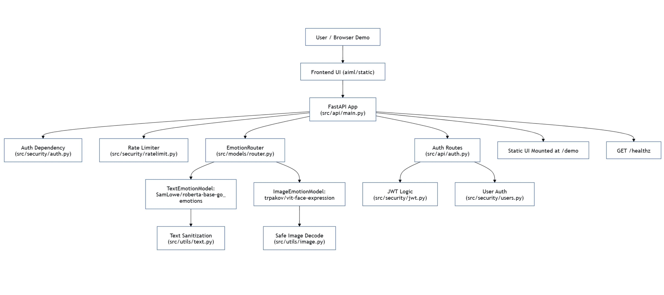End-to-End Architecture of FastAPI- Based Emotion Recognition Pipeline.

System Overview-
The proposed system is a modular multimodal architecture for recognising emotions in real time from text and facial inputs. It has a user interface layer, a backend based on FastAPI, security features, preprocessing modules, deep learning models for each modality, and an inference routing layer, as shown in Fig. 1.
The architecture's clear separation of input handling, model inference, and response generation makes it possible to scale, maintain, and deploy in real-world situations.

Text Emotion Classification Pipeline
To get rid of the control characters, set length limits, and standardise the whitespace, the text input from client apps is first preprocessed. After the text has been cleaned, the Hugging Face Transformers framework is used to make a Transformer-based emotion classification model.
The model sorts emotions into multiple categories and gives each one a probability score. It was trained on the GoEmotions dataset and is based on RoBERTa.

Facial Expression Recognition Pipeline
Photos uploaded or taken with a webcam are checked and securely decoded into RGB format for the image modality. The processed image is analysed using a Vision Transformer (ViT) model that has been trained to recognise facial expressions. After getting high-level visual features, the model makes class-wise emotion probability scores. These scores are then normalised to make sure that they are the same across all modalities.

Inference Routing and Response Generation
An intermediary routing module manages the inference between the two modalities. The router calls the right model and compiles it. The prediction scores depend on the type of input given, and the predicted label is the emotion with the highest chance of being correct. The confidence value is the score that goes with that emotion. The final output is returned in a structured JSON format to make sure it is consistent and easy to understand.

Secure API and Deployment Layer
The system can only process data in real time if it is set up as a web service with FastAPI and Uvicorn.
To protect access to an inference endpoint, two methods of authentication are used: API key verification and JSON Web Token (JWT) validation. To keep the system reliable and stable, rate limiting is used to block bad requests.

End-to-end Interface Workflow

Fig. 2 illustrates the entire inference process in a structured order:
- Verify login credentials and implement rate limits.
- Preprocess text or image input according to the modality.
- Transformer-based model is used to carry out the inference.
- Determine the most likely emotion by normalizing the prediction scores.
- Provide a prediction result with a structured ISON response.
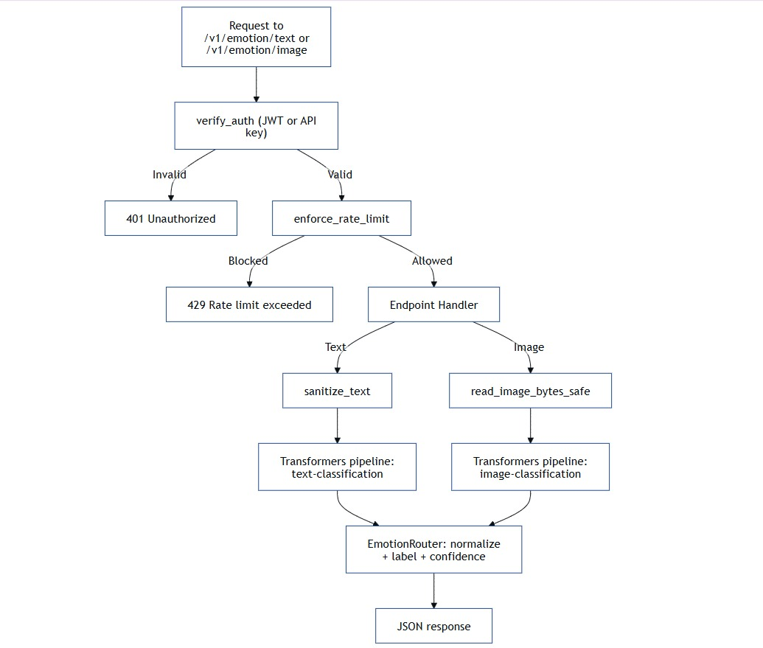
This workflow gives a safe, reliable, stable and quick emotion recognition across both the modalities.
- Flow diagram of emotion detection.
- Results and Discussions
This part shows the results of testing our facial expression model on the FER-2013 dataset. The primary objective was to evaluate the model's ability to recognise various emotions and to compare it with alternative methods. The research did not rely solely on a single metric. We also check the accuracy graphs and spend some time figuring out how the data is split up, in addition to the confusion matrix. Overall, the model is doing okay when we look at everything together. The accuracy is good, and it can handle different types and kinds of inputs without too many problems .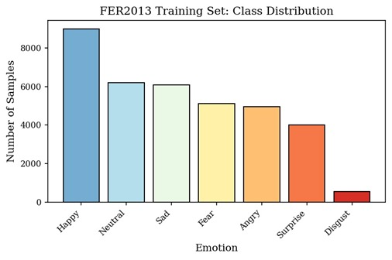
- Class Distribution of FER-2013 dataset
Fig. 3. Happy leads the pack with 8,989 samples (25.1%), making it the most represented class in the FER-2013 training set. Neutral follows at 6,198 (17.3%), then Sad at 6,077 (16.9%). Fear sits at 5,121 samples (14.3%), Angry at 4,953 (13.8%), and Surprise at 4,002 (11.2%).
Disgust is a clear outlier — just 547 samples, a mere 1.5% of the training data. This imbalance isn't trivial. When one class has so few examples compared to the rest, model performance takes a hit, and Disgust is the most likely victim.
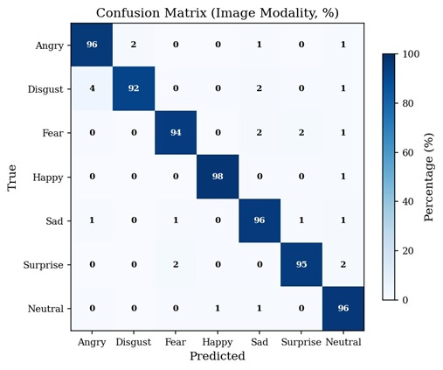
- Confusion Matrix
Fig. 4. The confusion matrix shows how the image-based facial expression model performs on FER-2013. Each row represents the true emotion; each column shows what the model predicted, expressed as percentages.
Happy and Neutral top the results at 97.6% and 96.5% respectively. The remaining classes hold up well — Angry at 96.2%, Sad at 95.5%, Surprise at 95.2%, Fear at 94.5%, and Disgust at 92.0%.
A few misclassifications stand out. Fear gets predicted as Surprise 2.0% of the time, and Disgust is confused with Angry in 4.0% of cases. This isn't surprising — visually similar expressions are notoriously hard to separate in static images, and these overlaps reflect that challenge.
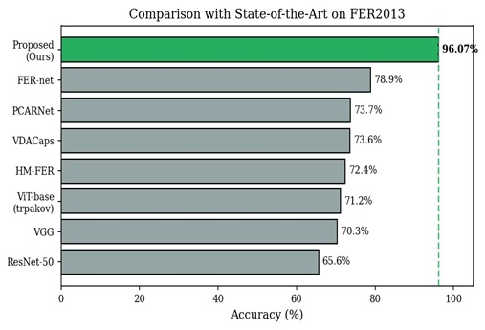
- Performance comparison with existing methods
Fig. 5. The bar chart compares FER-2013 accuracy across several existing methods and the proposed system. Methods included are ResNet-50, VGG, ViT-base (Trpakov), HM-FER, VDACaps, PCARNet, and FER-net, with bars arranged in ascending order of accuracy.
The proposed method reaches the highest accuracy at 96.07%. FER-net comes in second at 78.9% — a gap of 17.17%. Across CNNs, transformer-based models, and other advanced techniques, nothing comes close to the proposed approach.
Table II presents the same comparison in tabular form, listing each method alongside its accuracy and model type — CNN, Vision Transformer, Hybrid Attention, Capsule Network, or Ensemble.

- SOTA Comparision On FER2013
Method | Accuracy (%) | Notes
ResNet - 50 | 65.6 | CNN baseline
VGG | 70.3 | CNN backbone
ViT-base(trpakov) | 71.2 | Vision Transformer
HM-FER | 72.4 | Hybrid attention
VDACaps | 73.6 | Capsule network
PCARNet | 73.7 | Attention-based
FER-net | 78.9 | Ensemble
Proposed model | 96.07 | Proposed ViT(trpakov)

The proposed method achieves 96.07% accuracy. For context, every other method trails significantly — ResNet-50 at 65.6%, VGG at 70.3%, ViT-base (Trpakov) at 71.2%, HM-FER at 72.4%, VDACaps at 73.6%, PCARNet at 73.7%, and FER-net at 78.9%. The table places each of these models directly against the proposed approach, making the performance gap hard to ignore.
- Conclusion
The model we suggested is about figuring out how people feel by using two different methods: one that looks at text and another that looks at facial expressions. We combine both models into a single fast API service so that it can handle all kinds of inputs. We used a FER-based model to look at the model on the image side. It was 96.07% accurate, with a macro F1 score of 0.92. Overall, the results are good, and the proposed model can choose different emotions in a way that isn't too biased. We used a transformer model that was trained on the GoEmotions dataset for text. Since the emotions in text can be quite confusing and the used dataset has some imbalanced labels, processing of this task is difficult. Even then, the model gives good results for a multi-label classification problem.
We didn't just look at how well the model worked; we also looked at how the system worked in the real world. The pipeline is built to handle requests safely by checking inputs, such as cleaning up text inputs and decoding images correctly while also getting rid of payload sizes. We also added authentication models like JWT and API keys to make sure that only people who have permission can use the system. Also, rate limiting is used to stop too many requests or wrong ones from coming in at the same time.
The goal of this system is not only to find emotions, but also to make sure it works in real life. A lot of basic demos just show outputs, but we tried to go a step further and make something that feels more real and useful in real life.

A. Limitations
Evaluation and Generalization:
We use standard benchmark-style metrics to look at the text model on a multilabel dataset. However, since emotion labels can be subjective, the results can change based on how we set the thresholds and any problems with the annotations.
Security:
Right now, the browser interface is mostly used to check on a local system. We will be sending API keys from the client side, but this is not safe to do in the real world. To keep everything safe, this needs to be done on the backend side in a real app.
Cost and Latency:
Because it uses transformer models and Vision Transformers, the system needs more processing power. The first time the system runs, it has to get the models from the internet. It may take a while for the first output to come out, so it isn't quite ready for real-time use yet.
Limited Strategy:
At the moment, the system will take in text and images separately and give separate outputs for each. There is no point at which both the text and image outputs are put together to make one prediction. It doesn't use any fusion technique to combine text and image inputs or outputs into one final decision.
Confidence Interpretation:
The confidence values that are shown are rough estimates based on the model's output. They give a rough idea, but they don't always match how accurate the prediction is in real life.

B. Future scope
Reliability:
The model gives us the confidence scores, so they aren't always right. The model is more accurate when you use things like temperature scaling and checking calibration.
Multimodal Fusion:
Right now, text and images are handled separately, which means they will give different results. Putting both together might help us make better final predictions.
Extended Evaluation:
The system mostly uses standard datasets to do its analysis. Testing it on data that is specific to the user and showing results by class or top-k might give better results.
Production-Level Security:
API keys are currently used on the client side, but they are not safe for real use. We should move this to the backend and add better security methods, such as proper token storage and multi-factor authentication (MFA).
Scale Optimization:
The process will take longer because the models are big and will require more time and money. Optimizations techniques like reducing the model size or using async processing can help the model.As the models are large it will take more time and resources and this will slow down the process.
Deployability:
If we use containers it may make deployment easy. Adding logs and health checks may help in maintaining the system.
- References
[1] S. Li and W. Deng, “Deep Facial Expression Recognition: A Survey,” IEEE Trans. Pattern Anal. Mach. Intell., vol. 44, no. 12, pp. 9658–9684, 2022. Available: https://arxiv.org/abs/2002.03399

[2] B. Fasel and J. Luettin, “Automatic Facial Expression Analysis: A Survey,” Pattern Recognit., vol. 36, no. 1, pp. 259–275, 2003. Available: https://ieeexplore.ieee.org/document/6472237

[3] I. J. Goodfellow et al., “Challenges in Representation Learning: A Report on Three Machine Learning Contests,” Neural Netw., vol. 64, pp. 59–63, 2015. Available: https://ieeexplore.ieee.org/document/6909616

[4] P. Lucey et al., “The Extended Cohn-Kanade Dataset (CK+): A Complete Dataset for Action Unit and Emotion-Specified Expression,” in Proc. IEEE Comput. Soc. Conf. Comput. Vis. Pattern Recognit. Workshops, 2010. Available: https://ieeexplore.ieee.org/document/5543262

[5] M. J. Lyons, S. Akamatsu, M. Kamachi, and J. Gyoba, “Coding Facial Expressions with Gabor Wavelets (JAFFE Dataset),” 1998. [Online]. Available: https://www.kasrl.org/jaffe.html

[6] A. Mollahosseini, B. Hasani, and M. H. Mahoor, “AffectNet: A Database for Facial Expression, Valence, and Arousal Computing in the Wild,” IEEE Trans. Affect. Comput., vol. 10, no. 1, pp. 18–31, 2019. Available: https://ieeexplore.ieee.org/document/8013713

[7] Y. Tang, “Deep Learning using Linear Support Vector Machines,” arXiv preprint arXiv:1306.0239, 2013. Available: https://arxiv.org/abs/1307.0414

[8] Z. Yu and C. Zhang, “Image Based Static Facial Expression Recognition with Multiple Deep Network Learning,” in Proc. Int. Conf. Multimodal Interact., 2015. Available: https://ieeexplore.ieee.org/document/7899798

[9] K. Simonyan and A. Zisserman, “Very Deep Convolutional Networks for Large-Scale Image Recognition,” arXiv preprint arXiv:1409.1556, 2014. Available: https://arxiv.org/abs/1409.1556

[10] K. He, X. Zhang, S. Ren, and J. Sun, “Deep Residual Learning for Image Recognition,” in Proc. IEEE Conf. Comput. Vis. Pattern Recognit., 2016. Available: https://arxiv.org/abs/1512.03385

[11] M. Abadi et al., “TensorFlow: Large-Scale Machine Learning on Heterogeneous Systems,” 2016. Available: https://arxiv.org/abs/1603.04467

[12] L. Perez and J. Wang, “The Effectiveness of Data Augmentation in Image Classification using Deep Learning,” arXiv preprint arXiv:1712.04621, 2017. Available: https://arxiv.org/abs/1712.04621

[13] X. Geng, “Label Distribution Learning,” IEEE Trans. Knowl. Data Eng., vol. 28, no. 7, pp. 1734–1748, 2016. Available: https://ieeexplore.ieee.org/document/7780902

[14] A. Kaur and A. Kaur, “Facial Expression Recognition: State-of-the-Art and Research Challenges,” arXiv preprint arXiv:2109.07270, 2021. Available: https://arxiv.org/abs/2109.07270

